# Compass - Obtaining an Email Address and Managing Messaging Platform (MP) Notifications

General Information

Managing MP Notifications

Related Documents

**Description:** Procedures to optimize communication preferences, including obtaining email addresses, and the instructions on how to manage Messaging Platform (MP) notifications are included.

|  |
| --- |
| General Information |

Messaging Platform (MP) notifications are automated messages sent to the member based on the channels/programs they are enrolled in. For a list of MP notifications and their descriptions, refer to [Messaging Platform Alerts (110103)](https://thesource.cvshealth.com/nuxeo/thesource/#!/view?docid=d3dcf7c9-3cc9-4864-b6c1-165416474fa1).

Review member’s contact information and Add, Verify or Update member information to ensure member’s account is accurate and has the most up to date phone number, email address and mailing address. Reference the following work instructions as needed:

* [Compass - Add / Edit / Delete Phone Number (053256)](https://thesource.cvshealth.com/nuxeo/thesource/#!/view?docid=c37d4289-63b2-4732-a35c-c411cc26a29c)
* [Compass - Add / Edit / Delete Email Address (053409)](https://thesource.cvshealth.com/nuxeo/thesource/#!/view?docid=e01087c4-421c-4330-bcb3-81cb8cb45762)
* [Compass - Add / Edit / Delete Mailing Address (053255)](https://thesource.cvshealth.com/nuxeo/thesource/#!/view?docid=9cfb4422-7129-4bca-b1ea-f1d6fa964906)

MP notifications are available for every plan member, although clients may dictate specifics regarding methods of contact—called channels—and programs. The default channel may be a phone call, text message, or email, but the member can change the channel or opt out of program notifications by contacting Customer Care or accessing our web portal.

Prior to sending a message, MP reviews the communication channels where the member is enrolled and will pick the best channel to send that specific message. Only one channel delivers a given message at a time. This provides more flexibility for us to deliver the most effective message via the best channel for the member at the time of the communication.

**Example:** A lower priority informational message could be sent by email and a higher priority message requesting the member to act could be sent via text message.

The **Messaging Preferences** panel in Compass includes options to:

* Enroll a member in multipleMessaging Preference channels (i.e., Email, Text, and Call).
* Automatically turn on all program notifications for a new channel when selecting it from the **Enrollment Status** drop-down menu (except for programs designated as “opt in only”).
* Turn on (select checkbox) or off (de-select checkbox) MP notifications by individual program.
* Add/remove one or more of the following channels (Email, Text, Call, Secure Inbox) to one or more of the available programs.

 Only [Maintenance Medications](https://www.caremark.com/portal/asset/CVS_Caremark_Maint_DrugList.pdf) are eligible for Refill Reminder notifications.

**Notes:**

* If a program does not display in the **Messaging Preferences** **Programs** list, it is not available for the client.

**Example:** For the Full Drug Name program, the Text and Call channels are not available to select.

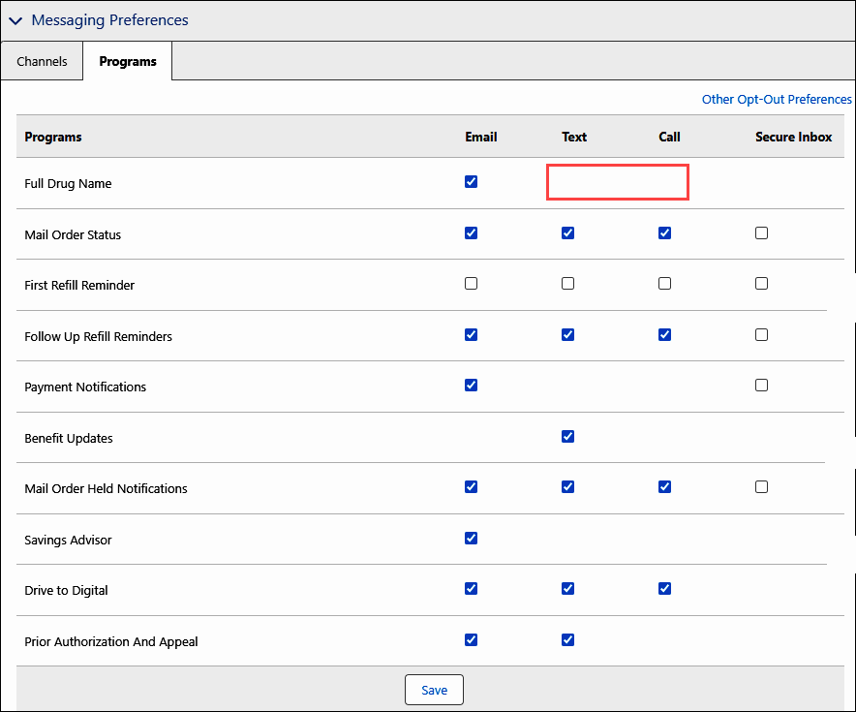

* Messaging Preferences are not available in Compass for members under the age of 18 years old. In the **Messaging Preferences** panel, users will see the message “Unavailable due to age limitation.” Their messaging preferences will align with the primary member (i.e., cardholder) by default.

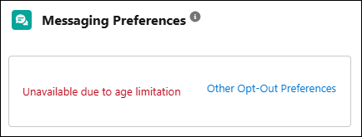

* In most cases, members under 18 years old cannot register for Caremark.com; their benefits information will appear on the primary cardholder’s web portal account. For specific clients, however, members under 18 years old can register for Caremark.com. These underage members will need to set their messaging preferences on the member web portal.

Top of the Document

|  |
| --- |
| Managing MP Notifications |

 CCRs **do not need to ask** the member if you can enable messaging preferences. CCRs should set up messaging preferences once phone number, text number, and/or email address are verified.

If a member is not receiving the alerts and the agent has verified the correct contact information, reach out to the senior team and have an IT ticket submitted.

Enroll member into **ALL** available Messaging Preferences.

|  |  |  |
| --- | --- | --- |
| **Step** | **Action** | |
| **1** | Review the **Messaging Preferences** panel of either the Member Snapshot Landing Page or the Claims Landing Page to determine which communication channel opportunities to discuss with the member.    **Member Snapshot Landing Page – Center Panel**    **Claims Landing Page – Left Panel**  **Authorization Notes:**   * Anyone who is fully authenticated on the member’s account and is authorized to order a refill for a member can set up the MP notifications. (Exceptions may apply based on client, search CIF.)   Only the member (or a POA, Legal Guardian, or Legal Conservator) can add or request changes to the default phone number or email address on the account. | |
| **2** | Discuss with the member that we can send them Messaging Platform notifications via Email, Text, and Call.  **Goal:** Enroll the member in as many communication channels as possible.  **If the member is not enrolled in MP notifications but their information is already listed:**  We can send you important updates by text, email, and call. I will update your account so that you receive these messages.  **If the member is enrolled in some, but not all MP notifications:**  I see that you are already enrolled in [text/email/call] notifications. I will update your account so that you receive these messages via our other communication channels. If you are enrolled in more than one channel, we will choose the best way to deliver each notification, so you do not get duplicates.  **Notes:**   * If a member is enrolled in multiple channels, they will not receive duplicate messages. * Members are also able to make and update these selections on the Communication Preferences screen of the member web portal. * The member will need to “Opt In” to the Full Drug Name program or they will only receive abbreviation of Drug Name. * No protected health information (PHI) is disclosed in MP email, phone, or text message notifications unless the member “Opts In” to the Full Drug Name program. The copies of MP notifications sent to the member’s Secure Inbox on the member website (if that option is selected) may contain PHI. * None of the notifications (regardless of format) or other messaging will violate any privacy laws. The messages do not reveal specific information about your medications, health conditions, or other PHI in a non-secure way unless you specifically request it. | |
| **3** | Verify the **contact information** for the member. The following information is required for each channel:   * **Email:** Valid Email Address * **Text:** Valid Phone Number without an extension * **Call:** Valid Phone Number without an extension   **Notes:**   * The profile must display a valid email address in the Email Address section of the Contact Information panel before it can be selected and enrolled as a preference under Channels. * Multiple family members can use the same email for MP notifications. * For text messages, there are no limits set on time of day. They are received at any hour. * For phone calls, the member’s zip code listed under the Primary Home address is used to determine local times. | |
| **4** | Make changes to the member’s contact information as needed within the appropriate sections of the **Contact Information** tab on the Member Snapshot screen, then proceed to the next step. Refer to each of the following work instructions as needed:   * [Compass - Add / Edit / Delete Email Address (053409)](https://thesource.cvshealth.com/nuxeo/thesource/#!/view?docid=e01087c4-421c-4330-bcb3-81cb8cb45762) * [Compass - Add / Edit / Delete Phone Number (053256)](https://thesource.cvshealth.com/nuxeo/thesource/#!/view?docid=c37d4289-63b2-4732-a35c-c411cc26a29c) * [Compass - Add / Edit / Delete Mailing Address (053255)](https://thesource.cvshealth.com/nuxeo/thesource/#!/view?docid=9cfb4422-7129-4bca-b1ea-f1d6fa964906)   Only the member, Power of Attorney (POA) form on file, or a third party that an authenticated member has given permission to speak on their behalf can add or update the email address.    **Notes:**   * If the **Don’t Ask for Email** checkbox is checked: The member may have previously indicated that they do not have an email address to share. Acknowledge this but attempt to update this information.   **Example:**  I see you previously did not have an email address to provide. Do you have one we could add today for messaging alerts about your orders?   * If the member does not want to be asked for the email address, complete a **Procedural Transfer** to the Senior Team to place a permanent Alert on the member’s account. * If the member doesn’t want an Email Address on file, click the **Don't Ask for Email** checkbox, then **Save**. This will disable the **Email Address** box. * To enable the **Email Address** box, click the **Don’t Ask for Email** checkbox again to deselect it, then **Save**. * For Research Cases, the **Email Address** field and **Don’t Ask for Email** checkbox will be **read only**. | |
| **5** | As a result of your discussion with the member, enroll the member in the appropriate **Channels**.     1. From the **Messaging Preferences** section of the **Contact Information** panel, select the **Channels** tab. 2. Click the appropriate channel’s **Enrollment Status** dropdown and select a valid phone number/email address.   **Note:** The **Enrollment Status** for each Channel (Email, Text, Call) displays one of the following:   * + **Not Enrolled:** The member is not enrolled in the communication channel.   + **Member Opted Out:** The member has previously chosen not to receive communications via the channel.   + **Member Email Address or Member Phone Number:** The member has previously enrolled to receive communications via the channel.  1. Click **Save**.   **Result:** A confirmation message displays. All available Programs are automatically selected for the newly enrolled Channel (except for programs designated as “opt in only”).  Do not proactively offer to review the Programs list or opt members out of a certain Program’s communications.  When the user moves from the **Channels** tab to the **Programs** tab without saving their changes, a “Save changes in Messaging Preferences channel?” message will display.   * To make further changes, click **Continue Editing**. * To discard changes, click **Discard Changes**. * To keep changes, click **Save**.     Refer to the following scenarios as needed: | |
| **If the…** | **Then…** |
| Member enrolls in Text or Call MP notifications | The following pop-up window displays. Read the required message to the member and then click **OK**.   * If the member does NOT agree to message and data rates, click **Cancel**. Inform the member they will not be enrolled in Text or Call MP notifications. |
| Member indicates they do not want to receive MP notifications about certain programs | Advise the member they are able to update their messaging preferences and make program-specific selections. Proceed to the next step.  Do not proactively offer to review the Programs list or opt members out of a certain Program’s communications.  **Programs Include:**   * Full Drug Name * Mail Order Status * First Refill Reminder * Follow Up Refill Reminders * Payment Notifications * Mail Order Held Notifications * Savings Advisor * Prior Authorization and Appeal |
| Member chooses to Opt Out of any current messaging channels | From the **Enrollment Status** dropdown for the channel, select **Member Opted out**, then click **Save**.    **Result:** Member will be Opted Out of selected Channels and any Program MP notifications will automatically be removed. |
| User tries to opt the member out of the required Messaging Preferences Channel for Auto Refill and/or Auto Renewal programs | A message will display “Member is signed up for Auto Refill/Auto Renewal, therefore cannot opt out of a Message Preference Channel.”  When this error message displays, the Messaging Preference update is not saved. |
| Phone number or email address displays in red font on the **Contact Information** tab. | The phone number or email address has been flagged as Invalid.     * If information is **Correct:**   Sometimes email addresses and phone numbers may show as invalid even though they are not. The invalid indicator can be cleared by clicking the **Reset** button in the corresponding section of the **Contact Information** panel.   * + - Email addresses are flagged as invalid if recent email messages are caught in spam filters or the message “bounces.”     - Phone numbers are flagged as invalid if the phone is disconnected, busy, or does not have voicemail. MP attempts to contact members two times via phone before flagging a phone number as invalid. * If information is **NOT** **Correct** refer to the appropriate work instruction to update:   + - [Compass - Add / Edit / Delete Phone Number (053256)](https://thesource.cvshealth.com/nuxeo/thesource/#!/view?docid=c37d4289-63b2-4732-a35c-c411cc26a29c) * [Compass - Add / Edit / Delete Email Address (053409)](https://thesource.cvshealth.com/nuxeo/thesource/#!/view?docid=e01087c4-421c-4330-bcb3-81cb8cb45762) |
| **6** | After clicking **Save**, the following confirmation popup and message displays: **Example:** “Update member’s Messaging Preferences when updating email address.” Click **Close**.      **Result:** Updated information displays in the **Contact Information** panel. | |
| **7** | Assist the member with making individual program selections on the **Programs** tab of the **Messaging Preferences** section only if the member indicates one of the following:   * They do not want to receive communications about certain programs, * They want to set up program messaging on specific channels, or * They want the full drug name to appear in email communications.   **Note:** The Payment Notifications and Full Drug Name programs are only available through the Email and/or Secure Inbox Channels.  To enroll in the Full Drug Name program, you must be speaking to the member themselves, or the **caller must have** Power of Attorney (POA) form on file, or verbal permission from the member obtained on the call to speak with a third party on their behalf. No exceptions.   * **To Enroll:** If the member requests to enroll in certain communications for a specific program, locate the program name in the Messaging Preferences section, and check the box that corresponds to the program and communication type. After you check the appropriate box, click **Save**. * **To Unenroll/Disenroll:** If the member requests to disenroll them from a certain program, locate the program name in the Messaging Preferences section, and uncheck the box that corresponds to the program and communication type. After you uncheck the appropriate box, click **Save**.     **Result:** Applicable disclaimers display that need to be read to the member, including when adding email notifications for the Full Drug Name program. Read any disclaimers, then click **OK**.    Once the member’s Messaging Preferences have been successfully updated, a popup displays: “Messaging Preference Programs updated successfully!”    **Note:** If updates were not updated successfully, a message displays: “Messaging Preference Programs were not successfully updated.” | |
| **8** | Educate the member that they can use the Communication Preferences screen of the member web portal to update their messaging preferences in the future. | |

Top of the Document

|  |
| --- |
| Related Documents |

[Compass - Close an Interaction or Research Case (050011)](https://thesource.cvshealth.com/nuxeo/thesource/#!/view?docid=0296717e-6df6-4184-b337-13abcd4b070b)

[Customer Care Abbreviations, Definitions, and Terms Index (017428)](https://thesource.cvshealth.com/nuxeo/thesource/#!/view?docid=c1f1028b-e42c-4b4f-a4cf-cc0b42c91606)

[Compass - Two Way SMS Text Messaging (065143)](https://thesource.cvshealth.com/nuxeo/thesource/#!/view?docid=de50d0a0-5b6b-41c4-9416-24bb0d3ee005)

**Parent Document:** [CALL-0049 Customer Care Internal and External Call Handling](https://policy.corp.cvscaremark.com/pnp/faces/DocRenderer?documentId=CALL-0049)

Top of the Document

Not to Be Reproduced or Disclosed to Others without Prior Written Approval

**ELECTRONIC DATA = OFFICIAL VERSION / PAPER COPY = INFORMATIONAL ONLY**